**Property Details:-**

**Rooms :- 10Cottages**

**Guest :- 2 person each Room**

**Max Capacity :- 30 Person**

**Price :- 3000/ Cottage**

**Location :-**  <https://www.google.com/maps/place/Collection+O+Tapovan+Rise+Cottages+And+Cafe/@30.1284392,78.3182358,17z/data=!4m10!3m9!1s0x390917cd84f51cd5:0x5c701e88652ea268!5m3!1s2024-12-02!4m1!1i2!8m2!3d30.1284346!4d78.3208107!16s%2Fg%2F11kk6p01rc?hl=en&entry=ttu&g_ep=EgoyMDI0MTExOS4yIKXMDSoASAFQAw%3D%3D>

**Address:- Near Tabola conte cafe, Rise intercollege road, behind kriyayoga ashram, Tapovan, Rishikesh, Uttarakhand 249192**

**Amanites:-**

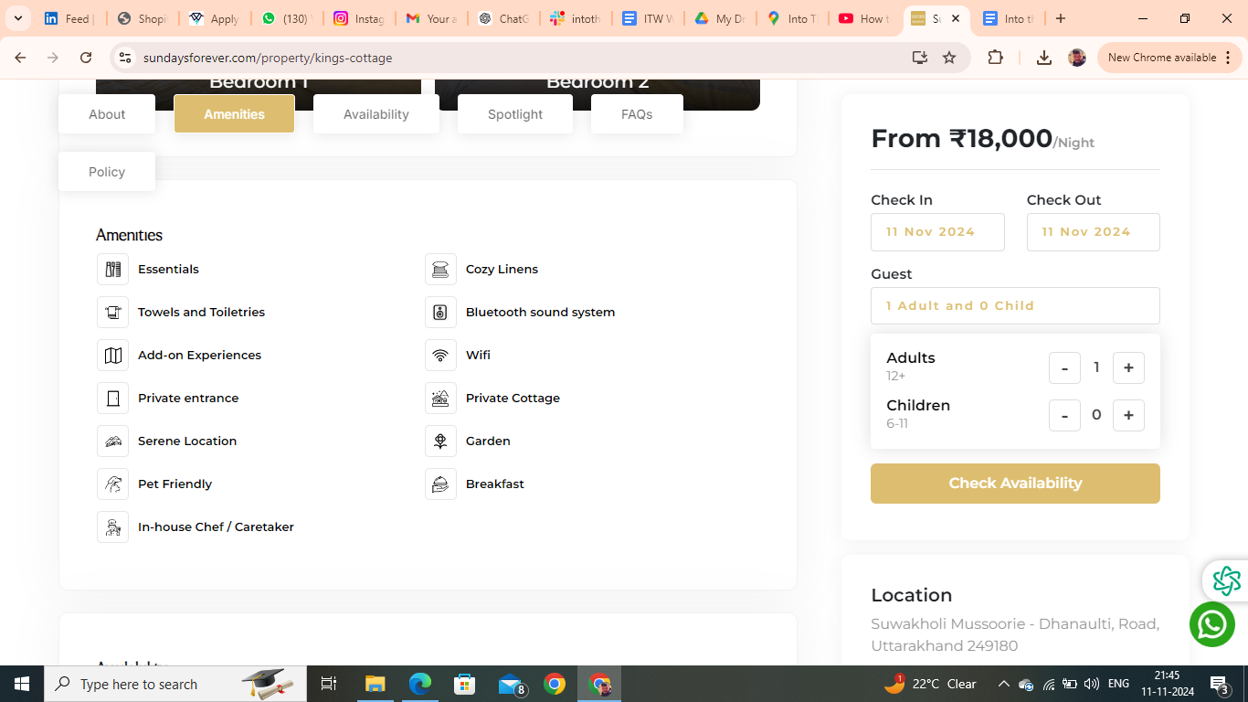

Amanites you have to remove are :- Essentials, Bluetooth Sound System

FAQs

**Is Driver and/or House-Help accommodation available?**

Driver accommodation depends upon the first come first serve basis. It is available at nominal charges a small room or Bunk bed with dinner and breakfast will be provided just nearby the property.

**Is parking available onsite or nearby?**

Free open parking is available onsite adjacent to our Cafe. There is ample car parking for 6-7 cars at the site.

**Is the Property suitable for a day picnic?**

Yes, the home has a garden/lawn area within the premises that could be used for outdoor picnic activities. Meals will be provided on site at an additional charge (per person, per meal). Please note that the maximum capacity for an overnight stay is 4 people.

**Is property pet friendly?**

We’re happy to welcome your furry friends at Into the Wild Stays! Please bring a pet bed along, as pets aren’t allowed on guest beds or any linen. Enjoy a comfortable stay for you and your pet in the heart of nature!

**Booking Policies**

House rules

* .Check-in: 12 PM Check-out: 10 AM
* Guest are requested to shut the windows and doors during the evening . as the property may be prone to insect and bug.
* Guest are not allowed to spill food or drinks over the upholstery or they will be charged at the time of checkout.
* Please Be mindful and keep the noise to the minimum after 10 pm.
* Passport, Aadhar, Driving License and Govt. ID are accepted as ID proof(s)
* Allows private parties or events

**Refund & Rescheduling Policy**

* Refund would be processed in 14 working days .
* Booking can be rescheduled till 15 days prior to arrival date depending upon the availability.
* Rs1000 plus applicable taxes will be charged for rescheduling .
* Rescheduling can be done only for the same property.
* If the tariff on the rescheduled date is higher than the initial booking date then difference is payable.

**Things you need to know**

* The full payment must be made for your booking to be confirmed
* Only the guest who have been accounted for are allowed at the Property
* Any damage to the property caused by the guest will be charged as per the actual cost of repair or replacement.
* Any commercial activity is strictly not permitted.
* Guests are earnestly requested to treat the home with care.
* Any damage to the property caused by the guest will be charged as per the actual cost of repair or replacement.
* Consider this as a homestay in mountains not a Typical Hotel Stay

Cancellation and Refund Policy

* Cancellation 12 days prior to arrival date 15 % will be charged.
* Cancellation 07 days prior to arrival date 50 % will be charged.
* Cancellation less than a week full retention would be applicable.
* Credit/Debit card cancellation will be charged 5 % extra.
* Cancellation policy for long weekends and special days .
* Cancellation 07 days prior to arrival date 50 % will be charged .
* Cancellation less than a week full retention would be applicable.

**About Tapovan Rise Cottages**Welcome to Tapovan Rise Cottages, nestled in the serene Upper Tapovan area of Rishikesh. Perfect for family getaways or trips with friends, this homestay offers a peaceful retreat with a charming café and opportunities to join rejuvenating yoga retreats. Experience the beauty of Rishikesh while enjoying warm hospitality and modern comfort.

**Things to Do at Tapovan Rise Cottages**

* **Yoga Retreats**: Immerse yourself in guided yoga sessions amidst tranquil surroundings.
* **Café Vibes**: Relax and unwind at the cozy in-house café.
* **Explore Hidden Waterfalls**: Discover secret cascades tucked away in nature.
* **Visit Laxman Jhula**: Walk across this iconic suspension bridge with scenic views.
* **Ganga Aarti**: Witness the divine evening aarti by the Ganges.
* **Adventure Sports**: Try activities like white-water rafting, bungee jumping, and trekking.